Below are sensitivity studies, but right here I want to document that a c_r(L) slope of 0.0057 micrometer^-1 comes from the following temperature/pressure combination:

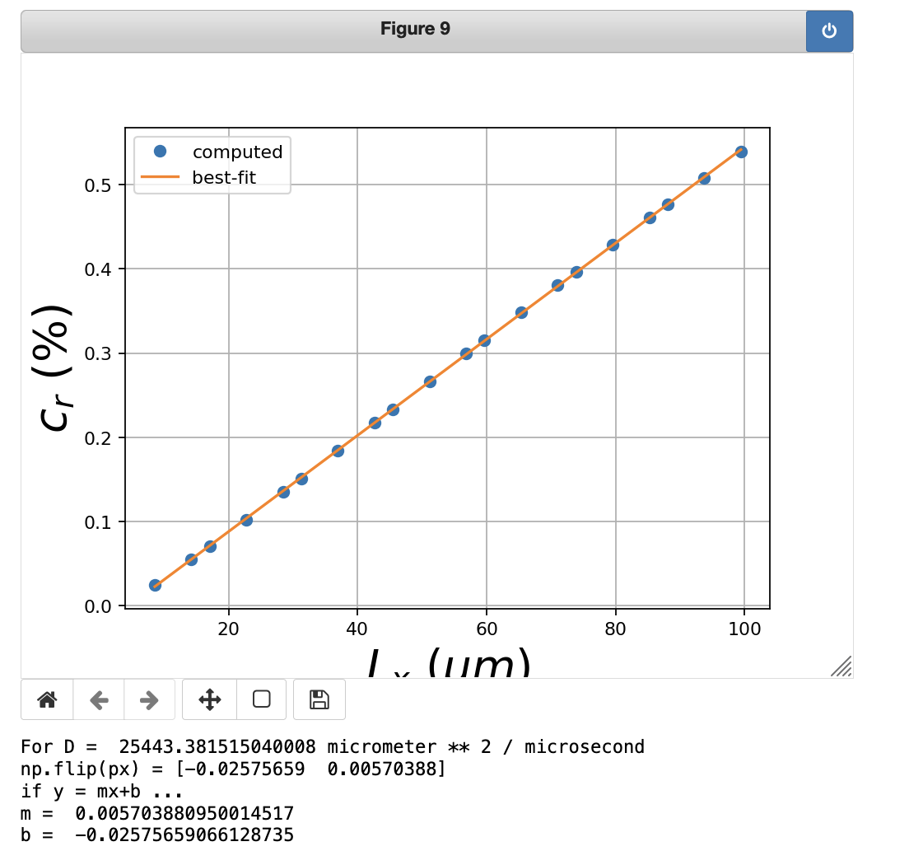

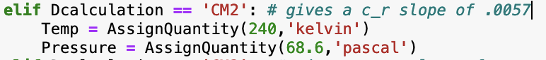

These are the results of default vaporfield_2d parameters:

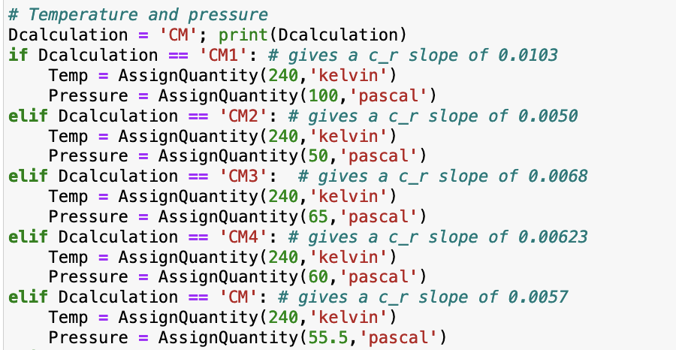

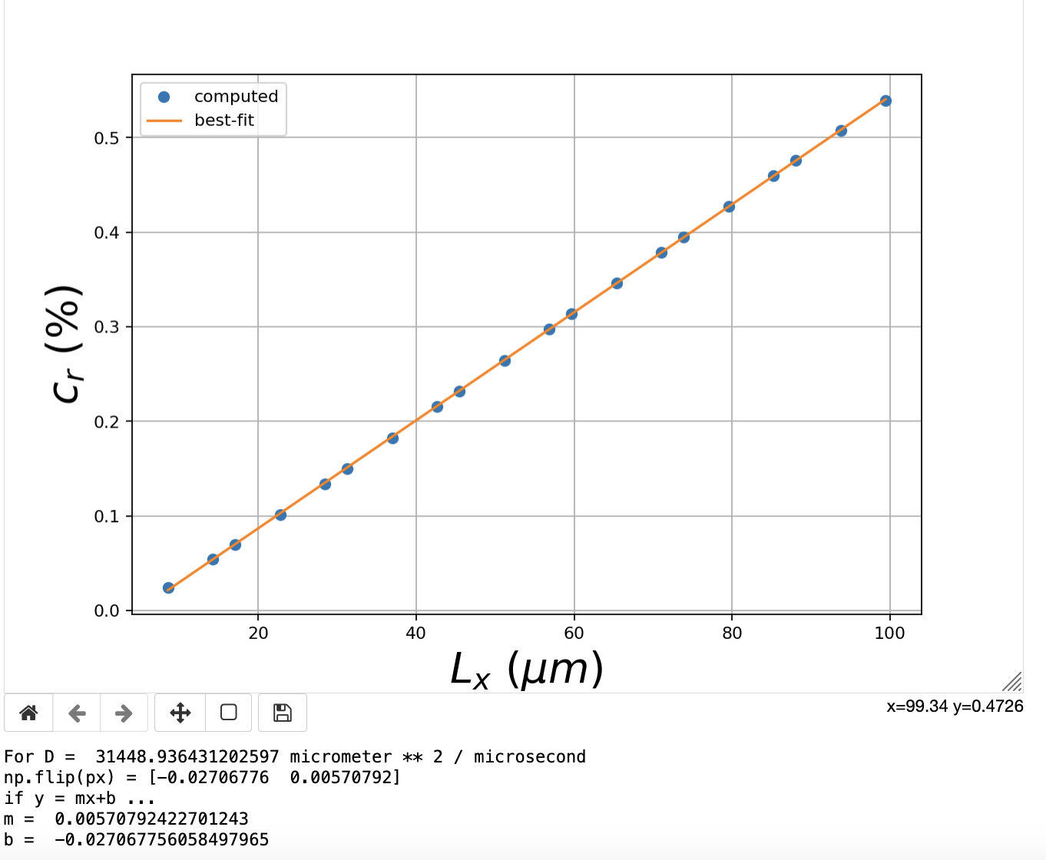

When I **increase** **sigmaI_far_field**, slope goes **down a little**

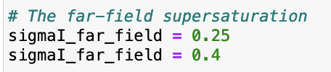

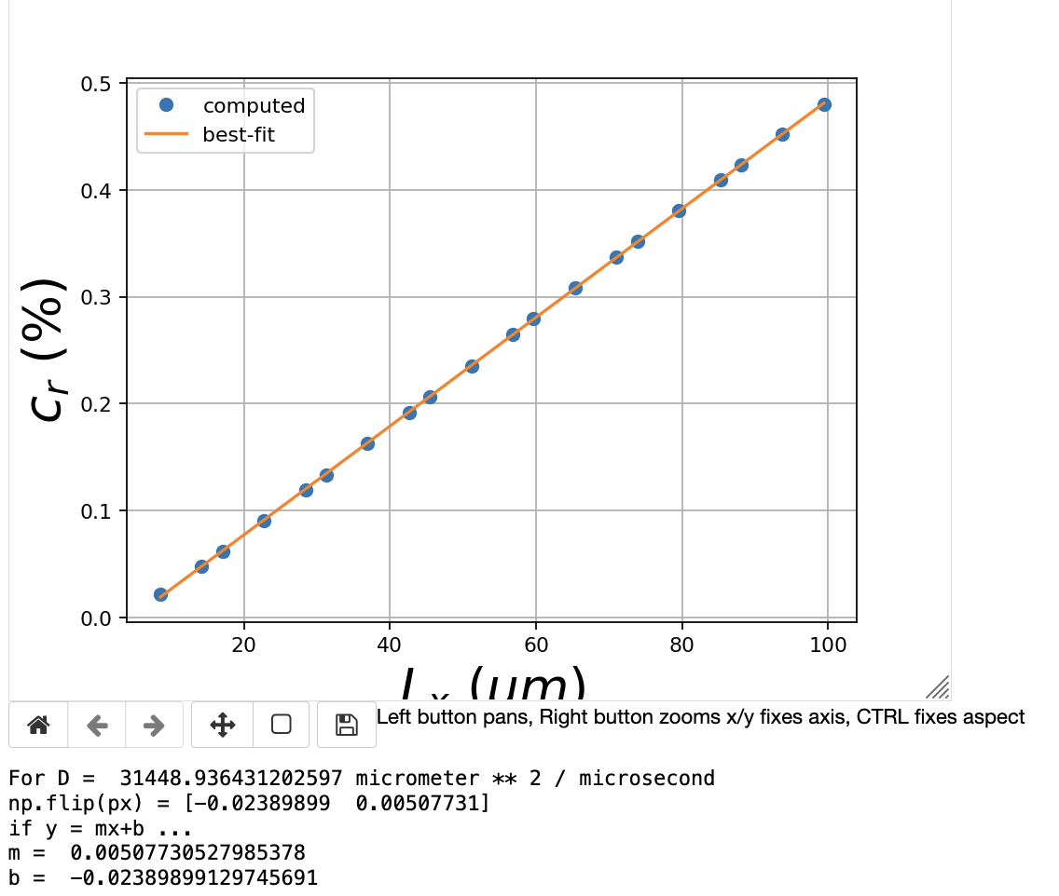

When I **increase the** **temperature** (which **increases Dvap**, and also affects the **Dirichlet** and **Neumann** conditions), the slope goes **down a lot**

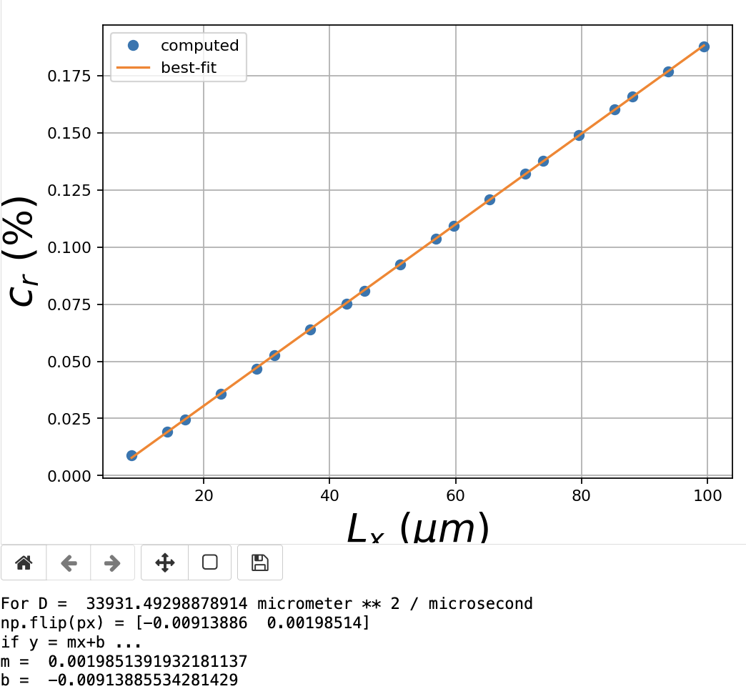

When I **increase the** **pressure** (which **decreases Dvap**), the slope **increases a lot**

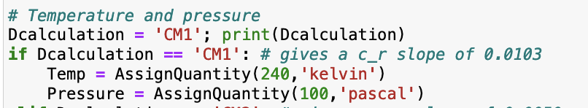

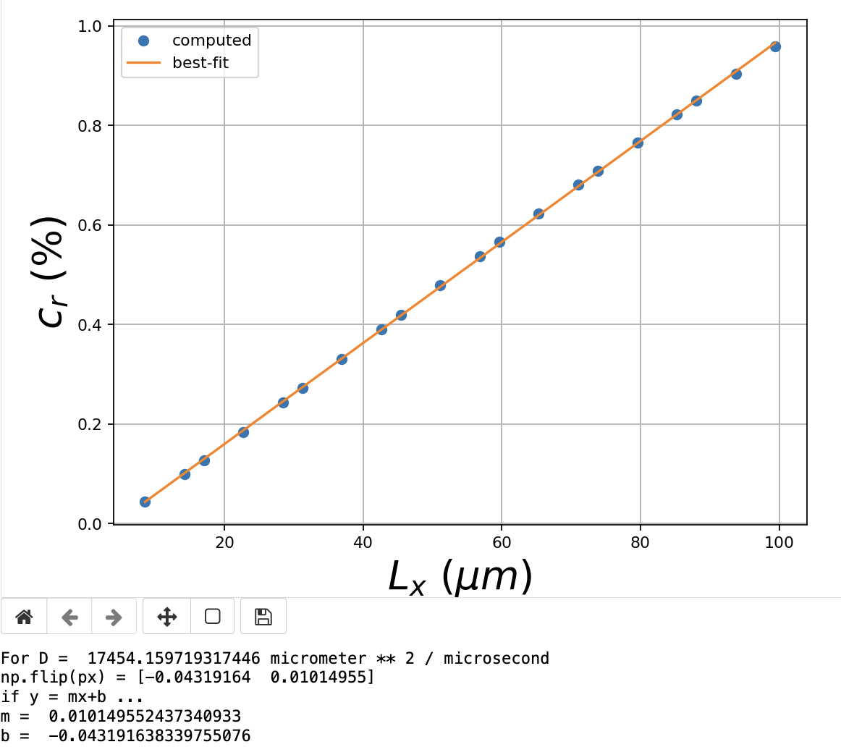

When I **increase sigma0**, **c_r is unchanged**

